Final Report — Relationship Between Trader Performance and Market Sentiment

Objective
The aim of this study is to explore the relationship between trader performance and market sentiment, understand how sentiment impacts trader behavior, and identify insights that can support smarter trading strategies.

1.Understanding Market Sentiment Trends:
We began by examining daily market sentiment scores over time.
This helped show how overall market mood fluctuates between fear, neutral and greed phases.
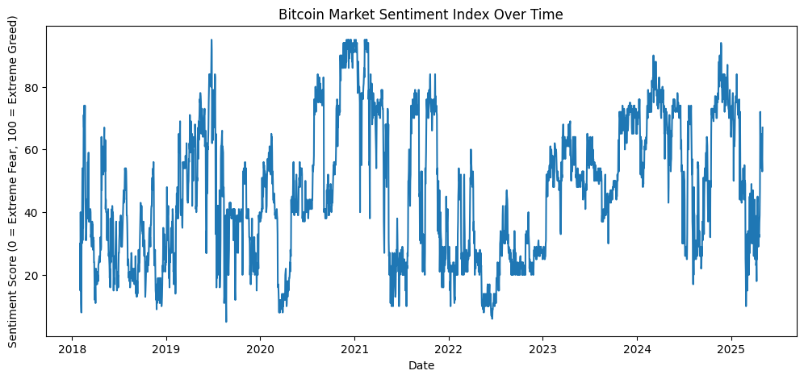
From this visualization, we observed repeated cycles of Extreme Fear → Neutral → Greed, reflecting how market confidence rises and falls over time.

2.Distribution of Sentiment States:
we checked how often each sentiment level occurred.
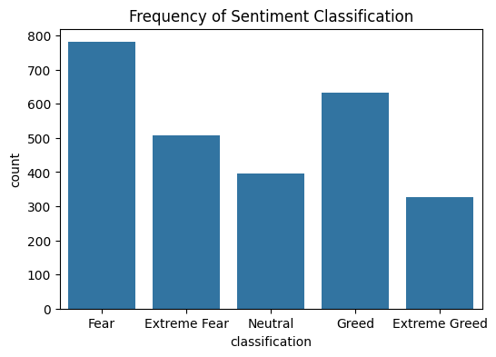
The majority of days fall under Fear and Neutral, while Extreme Greed and Extreme Fear are less common but more volatile periods.

3. Comparing Sentiment With Trader Profitability:
To explore the relationship between sentiment and trader earnings, we combined market sentiment data with daily trader PnL (profit and loss).
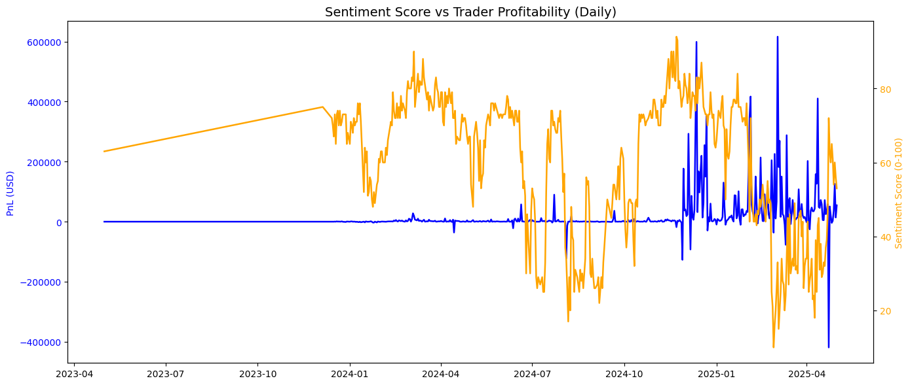
In this graph, we used two axes so that both sentiment values and PnL movements could be clearly seen.
This visual comparison highlights that large PnL swings tend to happen after major shifts in sentiment, especially when the market mood turns from Extreme Fear back toward Greed.

4. How Performance Changes Across Sentiment States:
To uncover deeper patterns, we grouped trader performance based on sentiment categories:
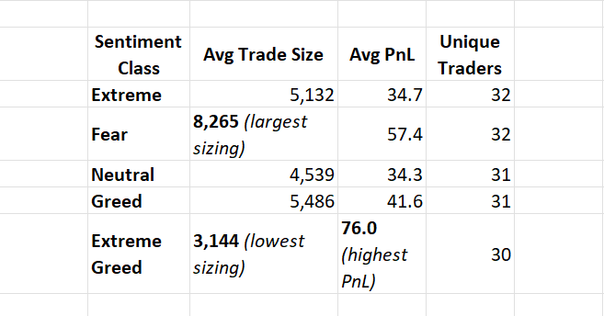
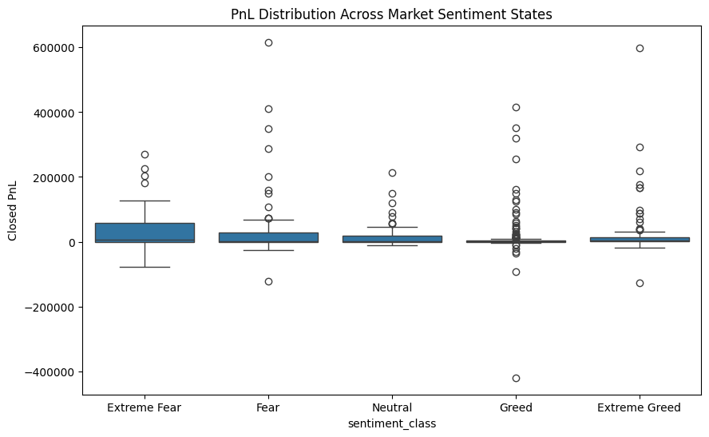
Key Observations
- Fear periods show the highest trade size, meaning traders take bolder positions when the market is uncertain.
- Extreme Greed has lower trade size but the highest PnL, suggesting only confident traders participate, often with strong conviction.
- Extreme Fear also shows positive PnL, indicating that contrarian trades during panic can be profitable.
- A statistical ANOVA test returned p = 0.017, confirming that differences in PnL across sentiment classes are significant, not random.
5. Hidden Patterns Discovered:
- Sentiment alone has weak correlation with PnL
(correlation = -0.083) → meaning mood does not directly control profit.
- Lagged correlation (-0.108) suggests
when sentiment rises sharply today (more greed), traders risk losing the next day due to overconfidence and late entries.
- Trader sizing behavior is emotional:
bigger trades occur during Fear, smaller trades during Extreme Greed.

6. Practical Insights for Smarter Trading Strategies
Based on the analysis, the following strategies may improve decision-making:
- During Extreme Fear:
Markets may be oversold. Carefully increasing exposure can capture rebound opportunities.
- During Fear:
Traders take their biggest positions here — momentum reversals are common.
- During Neutral sentiment:
Market direction is unclear — wait for clearer signals before large trades.
- During Greed:
Traders should reduce leverage and protect profits, because gains often slow down.
- During Extreme Greed:
Only small but strong trades perform well — avoid chasing hype, be selective.

7. Conclusion:
This study shows that market sentiment influences how traders behave and how much they risk, and that performance varies significantly across sentiment states.
While sentiment does not directly predict profits, Extreme Fear and Extreme Greed create conditions where strategic positioning can lead to better outcomes.
Overall, traders who reduce risk in Greed phases and cautiously capitalize during Fear phases appear to perform more consistently.
This relationship between emotion, behavior, and market performance can guide smarter decision-making in volatile crypto markets.

